**User Support for Paper Catcher**

How to Play

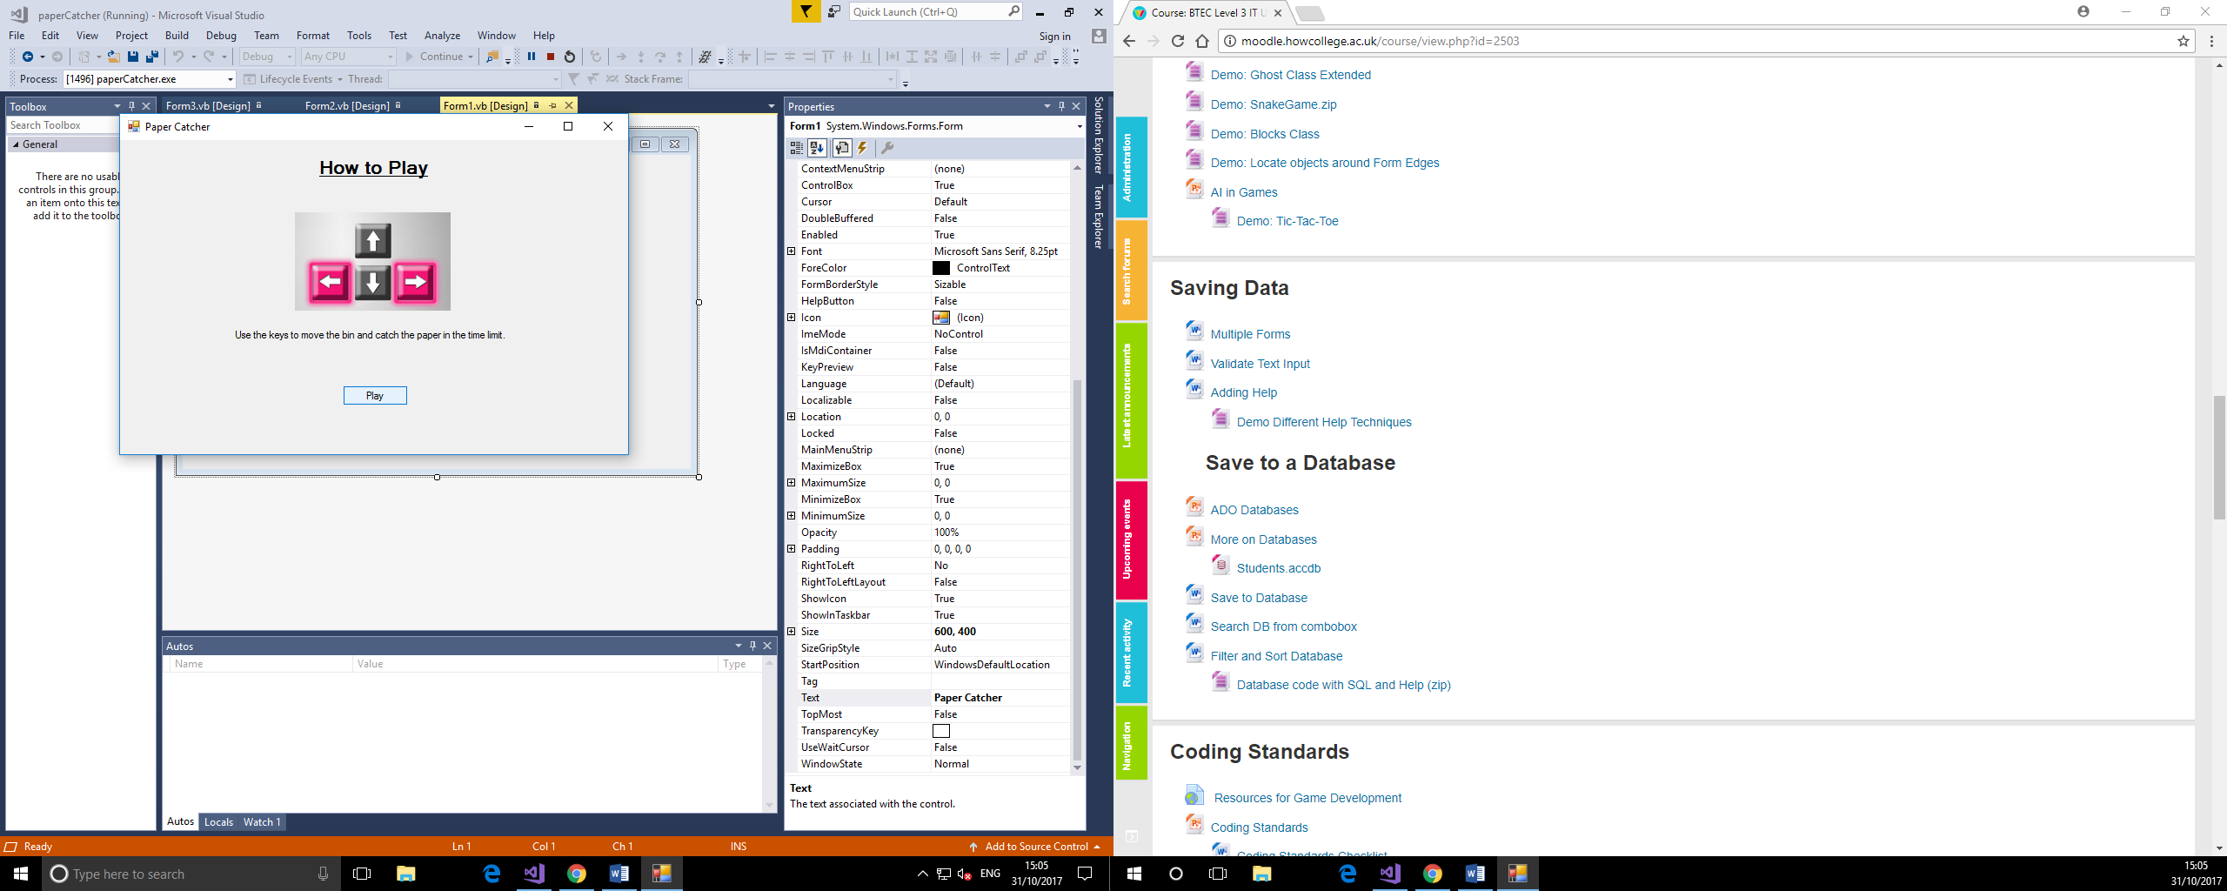

Use the arrow keys (left and right) to move the bin to catch as much paper as you can

Aim of Game

Catch the most pieces of paper that you can in the time limit. The game ends when the 1 minute is finished, and you can submit your score.

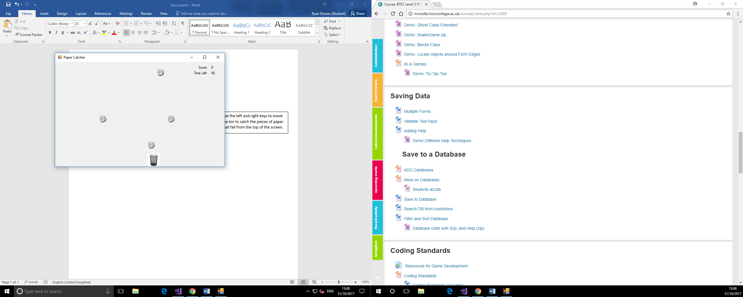

Scoring

The score is added by one each time a piece of paper is caught in the bin, and there is 1 minute to catch as many as you can.



When the time finishes the game ends, and the final score is displayed. You can then load this into the high scores table.

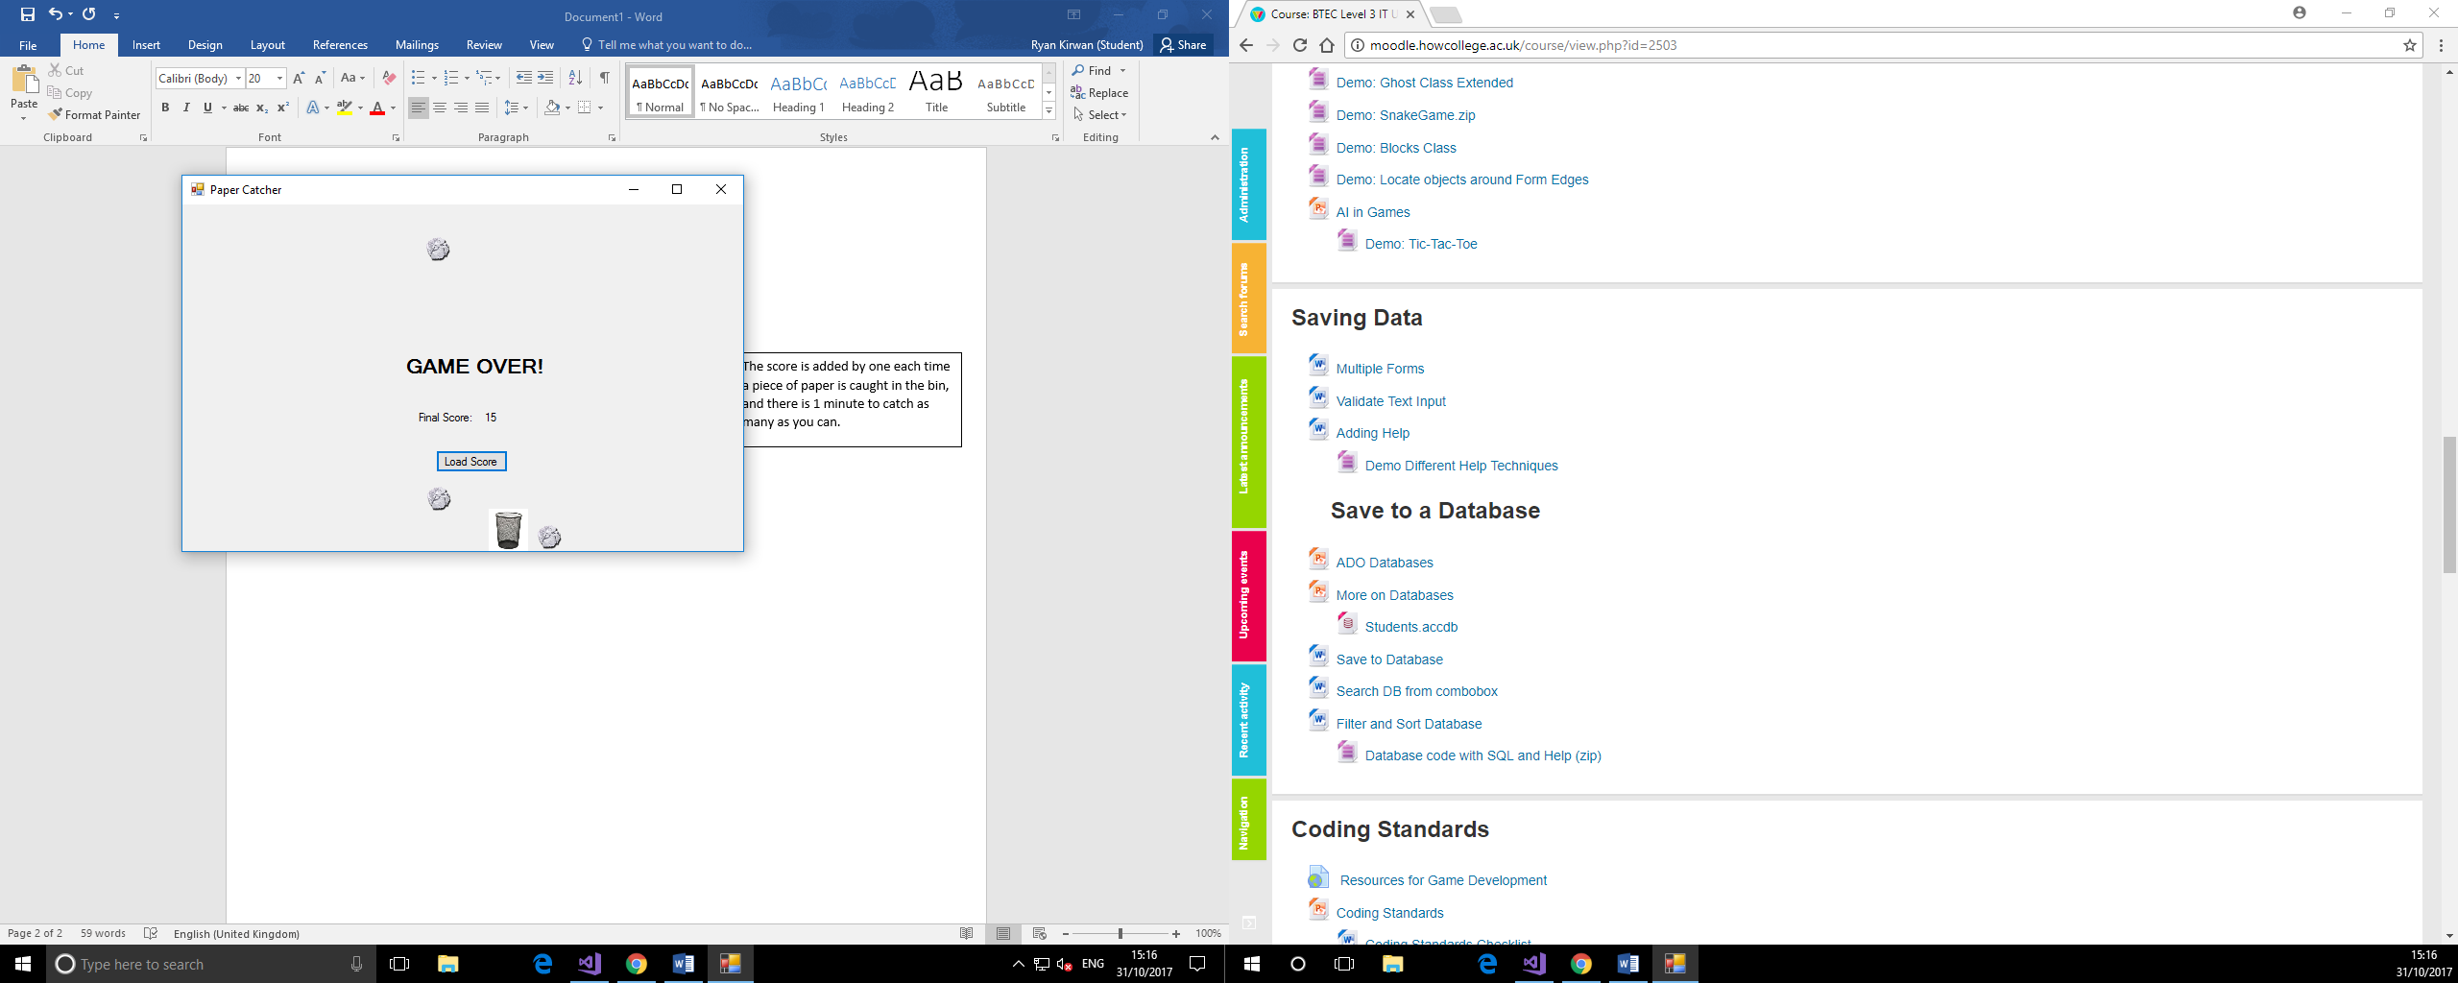

You can see the high scores of the game and add your score to this table. Put in a name to know yourself by, and add it to the table by clicking the add button.

